## 9.JavaScript Quizz *

Write a function that has the functionality of a quiz.

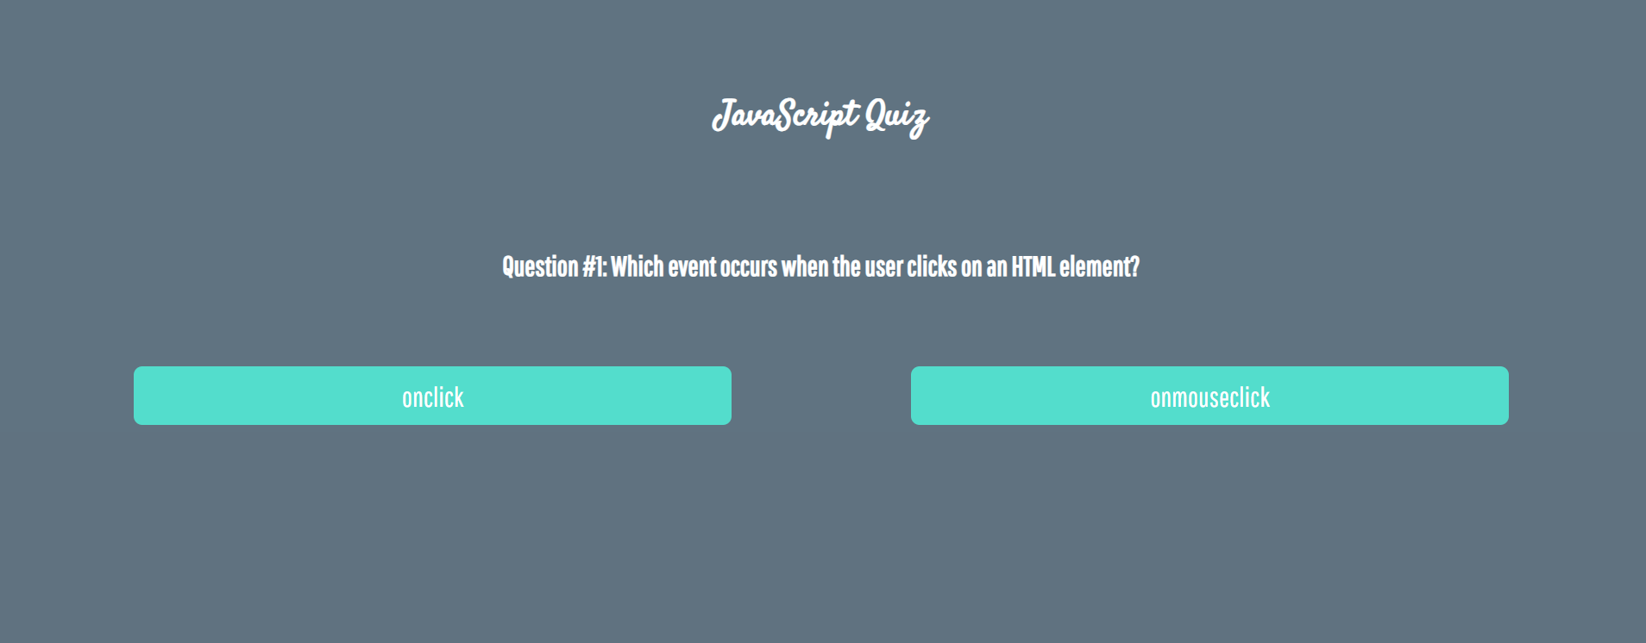

Three sections contain **one question** **and 2 possible answers.**

**The right answer is only one!**

When one of the **list elements is clicked,** the next section **must appear (if any…)**.

After all three questions have been answered, the results ul must **appear,** (Use **'none'** and **'block**' to hide and show the question sections), and the **results** must be added in the **h1**.

If all questions are answered correctly, you should print the following message:   
"You are recognized as top JavaScript fan!"

Otherwise, just print "You have {rightAnswers} right answers".

The right answers are:

* onclick
* JSON.stringify()
* A programming API for HTML and XML documents



